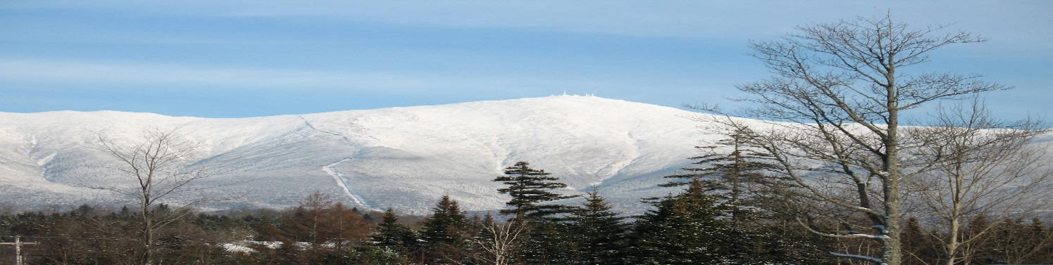
TOP OF NEW ENGLAND TOUR
September 14-18, 2015
HOTEL ACCOMMODATIONS: All hotel reservations are guaranteed until August 1, 2015
Monday, September 14: | - Bangor Fairfield Inn (Marriott)  300 Odlin Road  Bangor, ME | Reservation under: Batans Group  Room rates: two doubles or one king-- $119; includes complimentary breakfast  207-990-0001  http://www.marriott.com/hotels/travel/bgrfi-fairfield-inn-bangor
Tuesday, September 15: | - Meet in Bangor at the Cole Land Transportation Museum in the morning at 9 am. The museum features of a cross section of Maine’s transportation history through a variety of rare artifacts and exhibits; www.colemuseum.org  - Lunch to follow at the Towle’ lake house in Belgrade  - Depart for Town and Country Motor Inn, 2 Main Street, Gorham, NH | Reservation under: Batans Group  Room rates: two doubles or one king--$88; single--$78 OR request the following:  Stay and Eat package includes dinner and breakfast: 1 person for $119 or $159 a couple  Contact: Allison Jackson (or front desk) at 1-800-325-4386  www.townandcountryinn.com  Gorham area has several restaurants and pubs: Saaltz Pub, Libby’s Bistro,  J’s Corner to name a few
Wednesday, September 16 | Spend the day doing the following:  Option 1: Route 16 to Pinkham Notch to drive up the Mt. Washington Auto Road www.mtwashingtonautoroad.com  Option 2: Route 2 West to Rte. 115 to US 302 South to Brenton Woods to take the Mt Washington Cog Railroad www.thecog.com. (Reservations on the Cog recommended) You might like to take in the Mt Washington Inn for a drink, lunch or walk around (Goggle the Omni Mount Washington Resort)  Option 3: Route 16 South to North Conway to shopping outlets and/or ride the Conway Scenic Railroad (dining on the railway available) www.conwayscenic.com | Meet in late afternoon at The Fox Ridge Resort in North Conway  Reservations under: Batans Group  Room rates: 2 queens or 1 king: $99—includes breakfast buffet  1-800-672-0500  www.redjacketresorts.com/fox-ridge-resort  North Conway area has numerous restaurants, pizza shops and pubs: Sea Dog Brewing Co, Shannon Door Pub, May Kelly’s Cottage, Delany’s Tavern to name a few
Thursday, September 17 | Traverse the Kancamagus Highway (Rte. 113) to Lincoln, NH www.kancamagushighway.com  Option 1: Clark’s Trading Post in Lincoln: www.clarkstradingpost.com  Option 2: Flume Gorge and Visitor Center: www.cannonmt.com/flumegorge.html  Option 3: Take the tram to the top of Cannon Mountain for lunch and visit the ski museum at the base: www.cannonmt.com/cannontram.html | Drive to St Johnsbury, Vermont and meet at the Fairbanks Inn on  401 Western Ave  Reservations under: Batans Group  Room rates: 2 queens or 1 king--$119  1-802-748-5666 or reservations can be made online at: www.stjay.com access code is Batans  St Johnsbury has numerous restaurants and pubs: Kingdom Taproom, Anthony’s Diner, New East Garden, Kham’s Thai Cuisine to name a few
Friday, September 18 | Visit the Cabot Creamery: 2878 Main Street, Cabot, VT  https://www.cabotcheese.coop/cabot-visitor-center-tours | Continue to Stowe Vermont or one’s own itinerary

